A TECHNICAL REPORT ON STUDENTS INDUSTRIAL WORK EXPERIENCE SCHEME (SIWES)

HELD AT
DELAW COMPUTER INSTITUTE,
KARU, NASARAWA STATE

FROM: OCTOBER, 2023
TO: JANUARY, 2024

BY
CHRIS ABEL YUSUF
(ST/CS/ND/22/417)

A SIWES REPORT SUBMITED TO THE DEPARTMENT OF COMPUTER SCIENCE, SCHOOL OF SCIENCE AND TECHNOLOGY FEDERAL POLYTECHNIC, MUBI, ADAMAWA STATE, NIGERIA
IN PARTIAL FUFILMENT OF THE REQUIREMENTS FOR THE AWARD OF NATIONAL DIPLOMA (ND) IN COMPUTER SCIENCE

MARCH, 2024

ATTESTATION
I Chris Abel Yusuf hereby attest that I did my Industrial Attachment Program at Delaw Computer Institute, Karu, Nasarawa State between October, 2023, to January, 2024, and this report is prepared by me and submitted to the SIWES coordinator as required. I understand that all the information contained in this report are correct and will be penalized if found to be false. I also know that the SIWES coordinator may request for additional evidence as requested for reconciliation.

………………………………………… ………………………..
Chris Abel YUSUF DATE
(ST/CS/ND/22/417)

CERTIFICATION
This is to certify that Chris Abel Yusuf with a registration number ST/CS/ND/22/417 undergoes his industrial training SIWES at Delaw Computer Institute, Karu, Nasarawa State. In partial fulfillment of the requirements for the award of National Diploma (ND) in computer science, Federal Polytechnic, Mubi, as certified by the undersign officer.

Mr. Hyellamada Simon …………………………
DEPARTMENTAL SIWES CO-ORDINATOR DATE

DEDICATION
I dedicate this technical report to my lovely parents who gave me all the support and care throughout my SIWES program.

ACKNOWLEDGMENTS
I thank God Almighty for making me to undergo students industrial work experience scheme (SIWES) successfully.
My gratitude goes to my parent for their prayers, financial and moral support during my attachment.
I also appreciate the kind gesture of my brothers and sisters and those who supports me in prayers and contribution during my industrial attachment.
I whole heartedly thank my Head of department Mallam Kassim Mustapha, SIWES coordinator Mr. Hyellamada Simon and all lectures of Computer Science for their effort to ensure my success as their students.
I am greatly indebted to my co-SIWES students to mention, may God strengthen our relationship together and grant us academic excellence.
I sincerely thank you all for your contribution and support.

TABLE OF CONTENTS
Title Page - - - - - - - - - i
Attestation - - - - - - - - - ii
Certification - - - - - - - - - iii
Dedication - - - - - - - - - iv
Acknowledgements - - - - - - - - v
Table of contents - - - - - - - - vi

CHAPTER ONE: INTRODUCTION
1.1 Brief History of SIWES - - - - - - 1
1.2 Aims and Objectives of SIWES - - - - - 2
1.3 Roles of student - - - - - - - 2
1.4 Objectives of the report - - - - - - 2

CHAPTER TWO: HISTORY OF THE ORGANIZATION
2.1 Organizational chart - - - - - - - 3
2.2 Brief history of the organization - - - - - - 3

CHAPTER THREE: WORK EXPERIENCE I
3.1 Introduction to Computer- - - - - - - 5

CHAPTER FOUR: WORK EXPERIENCE II
4.1 Introduction to Networking - - - - - - 7

CHAPTER FIVE: SUMMARY, CONCLUSION AND RECOMMENDATIONS
5.1 Summary - - - - - - - - - 17
5.2 Conclusion - - - - - - - - 17
5.3 Recommendation - - - - - - - - 18
Reference - - - - - - - - - 19

CHAPTER ONE: INTRODUCTION
1.1 BRIEF HISTORY OF SIWES
SIWES was founded in 1973 by ITF (Industrial Training Funds) to address the problem of tertiary institution graduates' lack of appropriate skills for employment in Nigerian industries. The Students' Industrial Work Experience Scheme (SIWES) was founded to be a skill training programme to help expose and prepare students of universities, Polytechnics and colleges of education for the industrial work situation to be met after graduation.
This system facilitates the transfer from the classroom to the workplace and aids in the application of knowledge. The program allows students to become acquainted with and exposed to the experience required in handling and operating equipment and machinery that are typically not available at their schools.
Prior to the establishment of this scheme, there was a rising concern and trend among industrialists that graduates from higher education institutions lacked appropriate practical experience for employment. Students who entered Nigerian universities to study science and technology were not previously trained in the practical aspects of their chosen fields. As a result of their lack of work experience, they had difficulty finding work.
As a result, employers believed that theoretical education in higher education was unresponsive to the needs of labor employers. Thousands of Nigerians faced this difficulty till 1973. The fund's main motivation for establishing and designing the scheme in 1973/74 was launched against this context.
The ITF (Industrial Training Fund) organization decided to aid all interested Nigerian students and created the SIWES program. The federal government officially approved and presented it in 1974. During its early years, the scheme was entirely supported by the ITF, but as the financial commitment became too much for the fund, it withdrew in 1978. The National Universities Commission (NUC) and the National Board for Technical Education (NBTE) were given control of the scheme by the federal government in 1979. The federal government handed over supervision and implementation of the scheme to ITF in November 1984. It was taken over by the Industrial Training Fund (ITF) in July 1985, with the federal government bearing entire responsibility for funding.

1.2 AIMS AND OBJECTIVES OF SIWES
The Industrial Training Fund’s Policy Document No. 1 of 1973 which established SIWES outlined the objectives of the scheme as:
- Provide an avenue for students in Institutions of higher learning to acquire industrial skills and experience in their respective courses of study.
- Prepare students for the Industrial Work situation they are likely to experience after graduation.
- Expose students to work methods and techniques of handling equipment and machinery that may not be available in their Institutions.
- Make the transition from school to the world of work easier; and enhance students’ networks for later job placements.
- Provide students with an opportunity to apply their knowledge to real work situations, thereby bridging the gap between theory and practice; and vi. Enlist and strengthen Employers’ involvement in the entire educational process; thereby preparing the students for employment in Industry and Commerce.

1.3 ROLES OF STUDENT
- Attend SIWES orientation programme before going on attachment.
- Comply with the establishment’s rule and regulation.
- Arrange living accommodation during the period of attachment.
- Record all training activity done and other assignment in the log book.
- Complete SPEI from ITF, FORM 8 and get it endorsed by the employer for submission to the ITF.

1.4 OBJECTIVES OF THE REPORT
The objectives of the SIWES report are;
- To make thorough explanation of the work done during my four-month industrial training.
- To fulfill the requirement for national diploma in computer science.
- To contribute to the body of knowledge and to enhance the understanding of the writer about a similar or same job.

CHAPTER TWO: HISTORY OF THE ORGANIZATION
2.1 ORGANIZATIONAL STRUCTURE
Director
Admission officer
Exam officer
Application Lecturer
Networking Lecturer
Programming Lecturer
Maintenance Lecturer

Security
Cleaner

Figure 2.1: Organizational Chart

2.2 BRIEF HISTORY OF DELAW COMPUTER INSTITUTE
Delaw Computer Institute was founded in 2005 with the vision of providing high-quality computer education and training to students seeking to enhance their skills in the rapidly evolving field of information technology. Initially established as a small training center offering basic computer courses, the institute quickly gained recognition for its comprehensive curriculum and experienced faculty. Over the years, Delaw Computer Institute expanded its offerings to include a wide range of programs, including software development, networking, database management, and cybersecurity. Through strategic partnerships with industry leaders and continuous curriculum updates, the institute remained at the forefront of technological advancements, ensuring that students received relevant and practical training. Today, Delaw Computer Institute continues to empower individuals with the knowledge and skills needed to thrive in the digital age. With a focus on fostering creativity, critical thinking, and problem-solving abilities, the institute remains dedicated to shaping the next generation of IT professionals and contributing to the advancement of technology globally.

CHAPTER THREE: WORK EXPERIENCE I
3.1 INTRODUCTION TO Computer System
3.1.1 Monitors
Monitors are vital display devices used in various aspects of modern life. They provide visual feedback for computers, gaming, entertainment, and communication needs. Monitors come in diverse types and technologies to suit different preferences.
Uses of monitors
- Computing: Display output for computers and laptops.
- Entertainment: Viewing multimedia content like movies and videos.
- Gaming: Offering immersive gaming experiences.
- Communication: Facilitating video conferencing and online meetings.
Types of monitors
- LCD: Utilizes liquid crystal technology for energy-efficient display.
- LED: Illuminates display using light-emitting diodes for vibrant visuals.
- Curved: Provides an immersive viewing experience with a gently curved screen.
- Ultra-Wide: Offers expanded horizontal screen space for multitasking.
- Touchscreen: Allows interaction via touch-sensitive panels.
- Gaming: Optimized for gaming with high refresh rates and low response times.
3.1.2 Keyboard
Keyboards are essential input devices used for entering text, commands, and data into computers and electronic devices. They come in various types, including membrane, mechanical, ergonomic, wireless, gaming, and virtual keyboards, catering to different needs and preferences.
Uses of Keyboard
- Text Input: Primary for typing emails, documents, chatting, and internet searches.
- Command Input: Entering commands and shortcuts for software control and efficient navigation.
- Gaming: Specially designed for gamers with customizable features and optimized performance.
- Accessibility: Providing options for users with disabilities or special needs.
- Data Entry: Widely used in industries such as retail, healthcare, finance, and logistics.
- Function Keys (F1-F12):
Function keys, located at the top row of a keyboard, provide quick access to specific functions or commands within software applications and operating systems.
Examples:
- F1: Accessing context-sensitive help.
- F2: Renaming files or folders quickly.
- F3: Initiating searches within applications.
- F4: Opening or closing windows and menus.
- F5: Refreshing or reloading content.
- F6: Moving cursor within interfaces.
- F7: Initiating spell check.
- F8: Accessing boot menu during startup.
- F9: Refreshing display.
- F10: Accessing menus in software applications.
- F11: Toggling full-screen mode.
- F12: Opening developer tools or debugging consoles.
Various Parts of a Keyboard:
- Keys: Individual buttons for inputting characters, commands, and functions.
- Alphanumeric Keys: Letters (A-Z) and digits (0-9).
- Function Keys: Provide quick access to specific functions.
- Numeric Keypad: Located on the right side, for numerical input and arithmetic operations.
- Navigation Keys: Move cursor or selection within documents and interfaces.
- Enter Key: Confirms commands and creates new lines.
- Backspace and Delete Keys: Delete characters left or right of the cursor.
- Escape Key: Cancels or exits operations.
- Function Lock (Fn) Key: Activates secondary functions.
- Windows (Command) Key: Accesses system shortcuts on Windows keyboards.
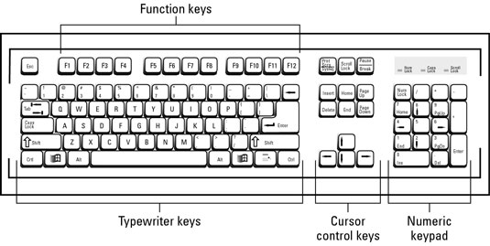
Figure 3.1: Diagram of a Keyboard

3.1.3 Introduction to Mouse
The mouse is a crucial input device that allows users to control the movement of a cursor on a computer screen. By clicking and dragging, users can interact with graphical interfaces, navigate menus, and execute commands efficiently.
Uses of Mouse
- Pointing and clicking for interface navigation.
- Dragging and dropping for file organization.
- Scrolling through documents and web pages.
- Gaming with precision and speed.
- Graphic design and CAD applications.
- Accessibility for users with disabilities.
Types of Mouse
- Optical Mouse: Uses LED or laser technology for precise tracking.
- Wireless Mouse: Connects via RF or Bluetooth for mobility.
- Gaming Mouse: Optimized for gaming performance with customizable features.
- Trackball Mouse: Utilizes a stationary ball for cursor control.
- Vertical Mouse: Ergonomically designed to reduce wrist strain.
- Touchpad: Built-in pointing device commonly found on laptops.
- Thumb Mouse: Operated primarily with the thumb for comfort and control.

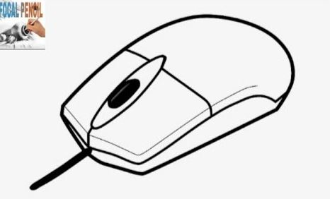
Figure 3.2: Mouse
CHAPTER FOUR: WORK EXPERIENCE II
4.1 INTRODUCTION TO NETWORKING
Networking, also known as computer networking, is the practice of transporting and exchanging data between nodes over a shared medium in an information system. Networking comprises not only the design, construction and use of a network, but also the management, maintenance and operation of the network infrastructure, software and policies.
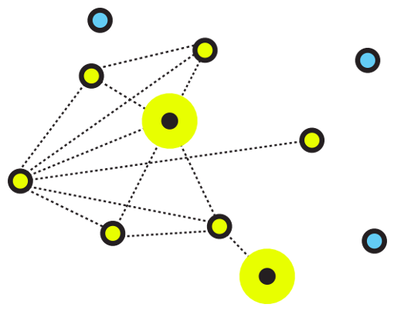
Figure 3.4: An illustrative image for networking

4.1.1 Types of Networking
There are two primary types of computer networking: wired networking and wireless networking.
Wired networking requires the use of a physical medium for transport between nodes. Copper-based Ethernet cabling, popular due to its low cost and durability, is commonly used for digital communications in businesses and homes. Alternatively, optical fiber is used to transport data over greater distances and at faster speeds, but it has several tradeoffs, including higher costs and more fragile components.
4.1.2 Components of Networking
Computer networking requires the use of physical network infrastructure -- including switches, routers and wireless access points -- and the underlying firmware that operates such equipment. Other components include the software necessary to monitor, manage and secure the network.
4.1.3 Networking wiring colour code and crimping.
How to make an ethernet cable
Purchasing Ethernet cables can be quite expensive and pre-made lengths are not always the length you need. Making Ethernet cables is easy with a box of bulk Category 5e Ethernet cable and RJ-45 connectors that are attached to the cut ends of your preferred cable length.
Bulk Ethernet Cable - Category 5e or CAT5e
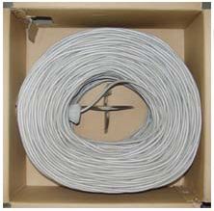
Figure 3.5: Bulk Ethernet Cable - Category 5e or CAT5e
(You may also use Category 6 or CAT6 cabling which has higher performance specifications and is about 20% more expensive than CAT5e.)
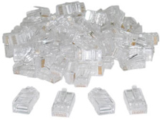
Figure 3.6: Bulk RJ45 Crimpable Connectors for CAT-5e
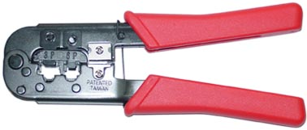

Figure 3.7: RJ-45 Crimping tool
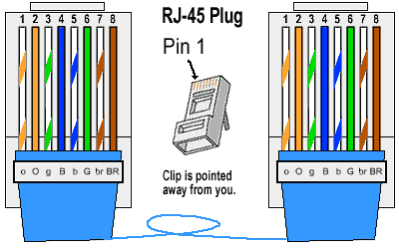

Figure 3.8: RJ45 diagram

4.1.4 Types of ethernet cables
There are two kinds of Ethernet cables you can make, Straight Through and Crossover.
Straight through Ethernet cables are the standard cable used for almost all purposes, and are often called "patch cables". It is highly recommend you duplicate the color order as shown on the left. Note how the green pair is not side-by-side as are all the other pairs. This configuration allows for longer wire runs.
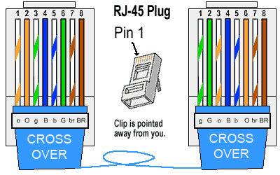

Figure 3.9: Straight through cable
Crossover Cables - The purpose of a Crossover Ethernet cable is to directly connect one computer to another computer (or device) without going through a router, switch or hub.
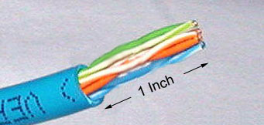
Figure 3.10: Cross over cable
Cut into the plastic sheath about 1 inch (2.5 cm) from the end of the cut cable. The crimping tool has a razor blade that will do the trick with practice.
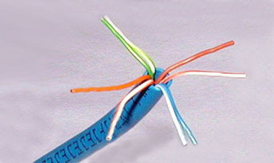
Figure 3.11: Unwind and pair the similar colors.
Pinch the wires between your fingers and straighten them out as shown. The color order is important to get correct.
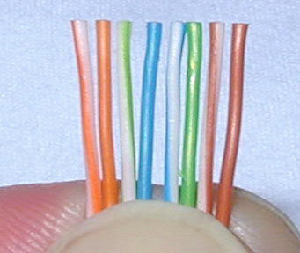
Figure 3.12: Colour order of cables
Use scissors to make a straight cut across the 8 wires to shorten them to 1/2 Inch (1.3 cm) from the cut sleeve to the end of the wires.
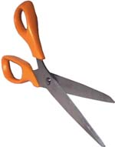
Figure 3.12: Scissors
Carefully push all 8 unstripped colored wires into the connector. Note the position of the blue plastic sleeve. Also note how the wires go all the way to the end.
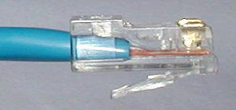
Figure 3.13: Inserting the wires
A view from the top. All the wires are all the way in. There are no short wires.
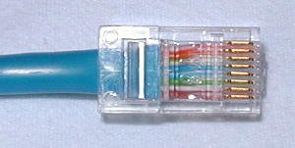
Figure 3.14: Top view of the inserted wires
Wrong Way - Note how the blue plastic sleeve is not inside the connector where it can be locked into place. The wires are too long. The wires should extend only 1/2 inch from the blue cut sleeve. Note how the wires do not go all the way to the end of the connector.
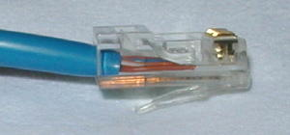
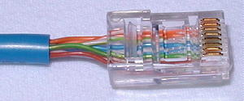

Figure 3.15: Wrong way of inserting the wires
Crimping the Cable ... carefully place the connector into the Ethernet Crimper and cinch down on the handles tightly. The copper splicing tabs on the connector will pierce into each of the eight wires. There is also a locking tab that holds the blue plastic sleeve in place for a tight compression fit. When you remove the cable from the crimper, that end is ready to use.
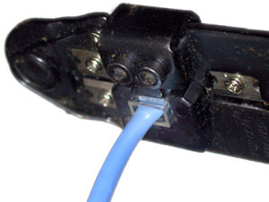
Figure 3.16: Crimping the cable

For a standard "Straight Through" cable, repeat all steps and wire color order on the other end of cable. For a cross-over cable, the other end will have a different color order as shown by the crossover picture above. Make sure to test the cables before installing them. An inexpensive Ethernet cable tester does this quite well.

CHAPTER FIVE: SUMMARY, CONCLUSION AND RECOMMENDATIONS

5.1 SUMMARY
The relevance of the SIWES program cannot be over emphasized considering the fact that it has significantly reduced the gap between my theoretical and practical knowledge about computer hardware and software, installations, maintenance and networking. The processes of communication which include data and telecommunication the use of switch in the networking and what networking is all about.
The program is indeed a commendable one in that it affords students ample opportunities of being exposed to good working relationship with colleagues and the field experience with customers. This little exposure has widened my knowledge about my course of study, not only that it has automatically changed my views about lift in general. The firm at large has taught me how to be independent of my own how to be conscious of my health and safety at its peak relating to the environment where I carried out my SIWES program. It was indeed a highly rewarding experience to be with Delaw Computer Institute, Karu, Nasarawa State.
5.2 CONCLUSION
In conclusion, I thank ITF in general for their effort towards the Student Industrial Training Scheme. The contribution that the industrial training offered to student will not be over emphasized. It has exposed me seriously to a certain depth and length of practical capability on Web Designs.
It has also acquainted me with the working condition, which I am expected to encounter in the near future. I will say that SIWES has a greater advantage on me, it has greatly exposed me to the practical application of all that I have been through in the school, SIWES is an experience that all student must pass through this is because it gives a full practical knowledge of what has been through in classroom.
Finally, I have a strong believe that this comprehensive based on the experience, I acquired during the industrial training scheme will convince every user training is not difficult.
I therefore strong conclude that the continuous existence of SIWES programme as it is very necessary since it plays a dominant role in the development of student of Computer Science in the acquisition of practical experience.
5.3 RECOMMENDATIONS
Below are the recommendations that should be given serious consideration so as alleviate the suffering of students undergoing SIWES.
Firstly, the Federal Government of Nigerian should make a positive effort in reducing the overall cost of production so that companies should be producing to fill capacity and accommodate SIWES populaces. Also, certain monthly allowance may be given to the student by company accepted then (student to ease transportation problem).
Secondly, the Industrial Training Fund (ITF), should try and increase the money paid at the end of SIWES to the student so as to justify the Cost of Living we experienced.
Thirdly, the period set for the SIWES should be increase to six mouths so as to enable the student involved and gain enough experience since it is widely believed that experience is the best teacher. Again, this period should also be in line with Nigerian University Commission curriculum for the university undergraduate student on industrial attachment.
Finally, the ITF official should please continue visiting the students, to ensure that what they are learning is in line with the ITF requirement.

REFERENCES
Edward, B. (2003). The Effect of SIWES on a student, Federal Ministry of Works, Lagos. Nigeria.
John, Doe (2008). Introduction to web development: responsive designs, McGraw Print New York.
Samuel, J. (2017). Visual Basic (VB) Tutorial Overview. Retrieved 25 July, 2022 from www.tutlane.com/tutorial/visual-basic

